Telco customer churn use case analysis

Problem statement:
Telco is a service provider company that is experiencing an increase in customer churn. This negatively affects the company’s targets and overall revenue. An analysis of this problem is required to find the contributing factors and the possible solutions to increase customer retention.
As-is: Telco provides month-to-month, one year long, and two-year-long contracts for any of the services such as streaming, online backup or tech support. There is 26.54% of customers churn and a potential loss of (currency is assumed) R2 862 926.
To-be: Telco wants to identify the high-churn-risk customers and proactively implement strategies to increase customer retention and therefore increase revenue while building a strong customer base.
The objective is to identify which customers are most likely to churn, what drivers of churn are, the potential revenue at risk, and opportunities to improve retention. The success criteria would be reduce churn by 10%, an increase in retention among high-risk customers, an increase in probability of long-term customer relationships and an improve of customer lifetime value.

Stakeholder identification and requirements -
- Customer: The customer wants reliable service, fair pricing, and a positive experience. Their needs include having efficient support, convenience paying, good pricing and reliable services. Relevant considerations for this stakeholder include whether they are receiving good customer support throughout their customer lifecycle (getting a contract, getting services, terminating, enquiring etc.), consider why they may be leaving, consider how to improve their customer experience, what kind of complaints or issues do they face. The business must identify factors that negatively impact customer retention and implement initiatives to improve customer satisfaction.

- Management: Telco management is concerned with the wellbeing of the business, being profitable and growing as a company. They need customer retention and revenue growth. Their needs from this use case analysis involve visibility of sales, losses, what impacts churn, strategies to improve customer retention, focus points for the business to make more money and identify where it is losing money and why. This stakeholder requires an understanding of churn trends and actionable measures to increase customer retention and achieve higher profitability.

- Marketing and sales: The marketing and sales teams are concerned with reaching targets relating to selling services, getting more customers and retaining customers. It is important to consider recognizing opportunities for upselling contracts, converting customers to contracts, building strong customer engagement and relationships, understanding customer patterns, gauging target audiences for marketing strategies and retention incentives. To make doing their job more effective, from this analysis they would require identification of high-risk churn customers, which customers to upsell to, what services or contracts to proactively engage with which kind of customers.

Data analysis –
Data assessment: There are 7043 total rows of data and 21 columns. Columns include customer ID, gender, senior citizen (yes/no – 1/0), has partner, has dependents, tenure, the services (phone service, multiple lines, internet service, online security, online backup, device protection, tech support, streaming tv, streaming movies, contract, paperless billing, payment method, monthly charges, total charges, and churn (yes/no)). The customer IDs are unique. IDs are numeric and text. Some Total Charges records are blank. No duplicate customer records identified. Minimal missing values. Few numeric data type fields (charges are decimal type), mostly text. 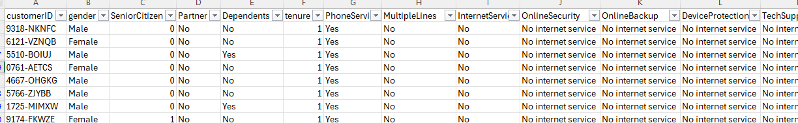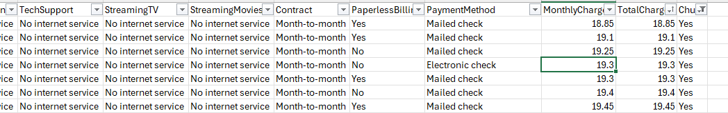
Data exploration: Total customers = 7043. Churned customers =1869. This makes up 26.56% of customers which have not been retained. Total charged revenue = R16 056 168.7 (currency is assumed). The customer tenure ranges between 1 and 72 months. The average being approximately 32 months. The average monthly charges faced by customers is R64.

Churn Analysis:
- Contract type with the highest customer churn – the month-to-month, compared to 1 yar and 2 years. 2 years has the lowest. This reflects that the longer a customer has a contract with Telco, the chances of retention increase. It would be a business opportunity to explore getting more customers on an annual contract as opposed to monthly.
- Tenure duration with the highest customer churn – the highest point of churn is at one month, customers that have been with the company less than 24 or 25 months are more likely to churn. This provides the business with an opportunity to focus on the period between getting a new customer and 24 months to implement strategies to increase retention probability.
- The payment method with the highest churn – the electronic check has the highest churn as a payment method while automatic bank transfer has the least. This gives business insight into payment convenience and how the customer experience affects the churn.
- The customers with higher churn – senior citizens are less likely to churn and those who aren’t senior have higher churn. This gives insight into the value proposition older customers have regarding the company and its services. The customers with dependents or partners also have less churn compared to the customers that don’t have dependents or partners. This gives perspective to Telco regarding their services and how customers that have dependents/partners place value on their services compared to those that don’t have dependents. It also provides a business opportunity where there are customers that are senior and have dependents and/or partners to create long-term customer relationships.

Recommended solutions –
- Promote annual contracts:
The month-to-month contract customers have the highest churn, so the opportunity lies with these customers to improve revenue. Offering an incentive to reduce month-to-month customer contract churn is a possible solution. A possible offer would be a discount on the 1 year or 2-year contract. These contracts have a lower churn rate so converting customers onto these contracts may increase customer retention. Getting 10% off or the first 2 months free can encourage customers to see value in longer term contracts instead of the month-to-month contract.
- Loyalty incentive:
The longer the tenure of customers, the higher the likelihood of customer retention. This gives Telco the opportunity to utilize loyalty incentives to keep customers. Since the period between 1 and 24 months has the highest churn, rewarding customers for reaching 12 and 14 months can increase customer retention. Focusing on new customers can also improve customer retention. Getting feedback on services rendered and monitoring customer satisfaction can help create strong customer relationships to reduce churn of high-risk customers which are new customers.

